**Mixer Module Description Document**

**1.Introduction**

The Mixer module of the AP80 series chip is a software abstraction module, serving as the axis of the audio path, and is suitable for audio systems developed based on AP80. The Mixer module isolates the coupling between various sources, and the tasks corresponding to each input source do not need to be concerned about the current status of other input sources. The concept of specific hardware audio channels can be downplayed.

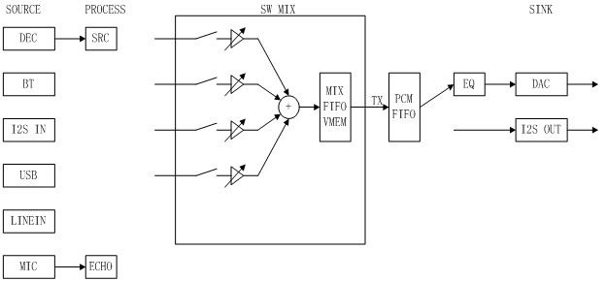

Figure 1 Simple diagram of the audio path structure

As can be seen from the above figure, from the perspective of the audio path, there are four important components: source(input source), process (sound effect processing), mix (software mixing), and sink (receiving end). The input and output of all modules are based on the memory buffer managed by the software. Thus, the process module can be assembled from the application layer to the required location, which is relatively flexible.

**2.Typical Applications**

The following is a mixer operation for the LineIn channel data

65 **uint16_t** Buf[512];

 66 uin32_t SampleCnt;

 67 MixerInit(**(void**\*)PCM_FIFO_ADDR, PCM_FIFO_LEN);

 68 MixerConfigFormat(1, 44100, MIXER_FORMAT_STERO);

 69 MixerEnable(1);

 70 MixerUnmute(1);

 71 **if**(MixerIsDone(1))

 72 {

 73     SampleCnt  =  AdcPmemPcmRemainLenGet();//Obtain the ADC sampling buffer data

 74     AdcPcmDataRead(Buf, SampleCnt, 0x03);

 75     MixerSetData(1, Buf, SampleCnt);

 76 }